This is a test document and nothing more.

Now I have to check if images work properly or not in the mark down.

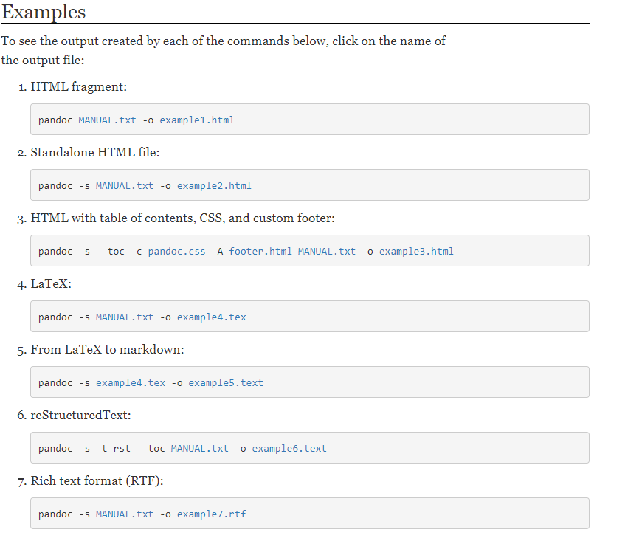

Working with images is not working

Now let’s try some math equations.

$$a^{2}+b^{2}=c^{2}$$

Math equations are not working then lets try styles and table.

# Heading

|  |  |  |
| --- | --- | --- |
| Column 1 | Column 2 | Column 3 |
| Now this looks good | Okay | missing |
| Don’t agree | No | why |